# INDEX

INDEX 2

LIST OF FIGURES 3

LIST OF TABLES 4

LIST OF ABBREVIATIONS AND ACRONYMS 5

LIST OF SYMBOLS 7

CHAPTER 1: INTRODUCTION 1

1.1 RELATED WORK 3

1.2 RESEARCH PROBLEM 8

1.3 HYPOTHESIS 9

1.4 OBJECTIVES 9

CHAPTER 2: SIGNAL AND SYSTEM MODEL 10

2.1 DOA estimation as a classification problem 12

2.2 Metrics and scoring 14

2.3 Classification model 16

CHAPTER 3: SIMULATION RESULTS 19

3.1 DATA GENERATION 19

3.2 SYSTEM MODEL DESIGN 20

3.3 ANALYSIS OF ML MODELS 21

3.4 RESULTS 21

References 21

# LIST OF FIGURES

Figure 1. Beamforming technique. 2

Figure 2. Overview of applications of ML in DOA [34]. 8

Figure 3. The System Model. 10

# LIST OF TABLES

Table 1. Taxonomy of the proposed ML to DOA estimation. 6

Table 2. Input parameter values of the GridSearchCV. 20

# LIST OF ABBREVIATIONS AND ACRONYMS

|  |  |
| --- | --- |
| AWGN----------------------- | Additive White Gaussian Noise |
| BC---------------------------- | Bagging Classifier |
| BF---------------------------- | Beamforming |
| CRLB------------------------ | Cramer-Rao Lower Bound |
| CVNN------------------------ | Complex-Valued Neural Network |
| DNN-------------------------- | Deep Neuronal Network |
| DOA-------------------------- | Direction of Arrival |
| DT---------------------------- | Decision Tree |
| EDT ------------------------- | Extra Decision Trees |
| FBLP------------------------- | Forward–Backward Linear Prediction |
| HBF-------------------------- | Holographic Beamforming |
| IoT --------------------------- | Internet of Things |
| ML---------------------------- | Machine Learning |
| MLE-------------------------- | Maximum Likelihood Estimation |
| MPNN----------------------- | Multilayer Perceptron Neuronal Network |
| NN---------------------------- | Neuronal Network |
| RSS--------------------------- | Received Signal Strength |
| SNR-------------------------- | Signal-to-Noise Ratio |
| SOC-------------------------- | Second Order Cone |
| SPNT------------------------- | Single-Pole-N-Throw |
| SSR--------------------------- | Sparse Signal Reconstruction |
| SVC-------------------------- | Support Vector Classification |
| SVD-------------------------- | Singular Value Decomposition |
| SVR-------------------------- | Support Vector Regression |
| UCA-------------------------- | Uniform Circular Array |
| ULA-------------------------- | Uniform Linear Array |
|  |  |
|  |  |
|  |  |
|  |  |
|  |  |
|  |  |
|  |  |

# LIST OF SYMBOLS

|  |  |
| --- | --- |
|  |  |
|  |  |
|  |  |
|  |  |
|  |  |
|  |  |
|  |  |
|  |  |
|  |  |
|  |  |
|  |  |

# CHAPTER 1: INTRODUCTION

For location services, the Direction of Arrival (DOA) method estimates the direction angle of a source transmitting a signal to a receiver. DOA estimation has been investigated for decades due to its important application in radar, sonar, seismology, astronomy and military surveillance. However, in recent years with the development of mobile networks, technologies and devices DOA has obtained new applications and therefore greater importance.

Mobile communication systems have been constantly evolving due to new applications and demands. Studies on 6G networks have begun with the aim of deploying it by 2030. One of the key technologies in 6G is expected to be Beamforming (BF), specifically Holographic Beamforming (HBF) [1]–[4]. BF is a technique that focuses a wireless signal towards a specific receiving device (see Figure 1), rather than having the signal spread in all directions from a broadcast antenna, as it usually would. Therefore, it is important to know the location of mobile devices and Internet of Things (IoT) terminals to direct the antenna beam of the radio BS. The resulting connection is faster and more reliable than it would be without BF.

The location technique for BF in 6G should be autonomous, reconfigurable, adaptive, and fast responsive. It is impossible to manually adjust the BF direction due to the extensive enhancement of the capacity of communication networks.

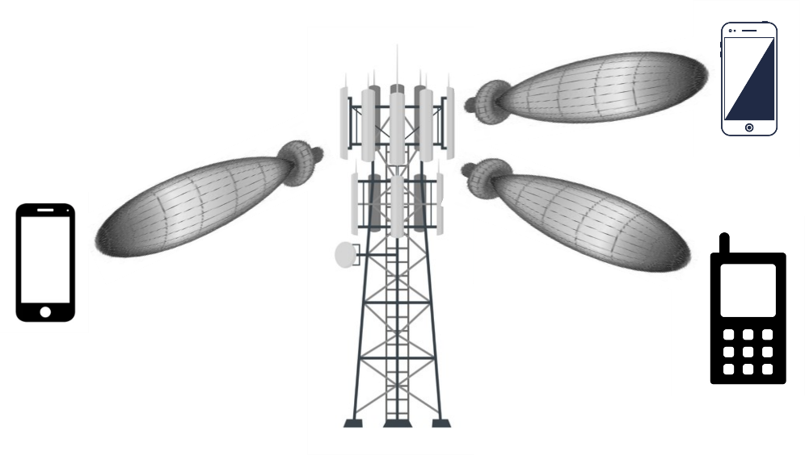

Figure 1. Beamforming technique.

On the other hand, the wide applications of drones in agriculture, industry, transport, communication, surveillance, and environment and the development of IoT means that the use of these devices is increasing [5]–[7]. However, drones can present a serious threat on civilian environments or sensitive areas such as airports and military bases. For example, in January 2015 a drone crashed at the White House [Jansen, 2020], compromising the security of the government building. On March 29th, 2016, a Lufthansa jet came within 200 feet and collided with a drone near Los Angeles International Airport (LAX) [8]. On October 12th, 2017, a Beech King Air A100 of Skyjet Aviation collided with a UAV as the former was approaching Jean Lesage Airport near Quebec City, Canada. The aircraft landed safely despite being hit on the wing [dro, 2020]. A hot air balloon carrying a certified pilot and two passengers was struck by a drone while flying near the Teton County Fairgrounds in Driggs, Idaho, United States, on August 10th, 2018 [Tellman, 2020].

Due to the security risk facts carried out by drones as discussed before, it is necessary to implement a drone DF system to confiscate or disable them. For the DF system, a signal from the drones is required to discover their directions. The drone’s owners do not want to be discoverable and they will not transmit such a signal that makes them vulnerable to a detection or DF system. Fortunately, most of the drones transmit a signal to communicate to their controllers in order to send images, video, and telemetry reports. Therefore, these signals are used for the DOA system to find the drone’s direction.

Due to the importance of the DOA estimation explained above, in this work a new method is presented and analyzed to find the azimuth angle and elevation of a signal from a receiving system.

## RELATED WORK

With the aim of knowing the DOA of a coming signal, different studies have been carried out. In general, the DoA estimation techniques can be broadly classified into conventional beamforming techniques, Maximum Likelihood Estimator (MLE), and subspace-based techniques. However, there are recent works on Received Signal Strength (RSS)-based DoA estimation [9]. Also in recent years ML has been applied to these techniques. This section will give a brief summary of these techniques and their main works. In addition, an observation of works that use ML to obtain better results in DOA with the different techniques. ~~Of the resulting methods, the best known techniques are Maximum Likelihood Estimator (MLE), the conventional estimation approaches, and the subspace-based approaches, Sparse Signal Reconstruction (SSR). In addition, DOA methods using ML are increasingly being defeated.~~

### The Maximum Likelihood Estimation

The MLE finds its estimates by maximizing the probability density function at the observed received signals with respect to the models parameters. In [10], is derived a deterministic MLE of multiple sources observed on the background of nonuniform white noise with an arbitrary diagonal covariance matrix. In [11], the performance of the MLE under conditions of low Signal-to-Noise Ratio (SNR) and a small number of array snapshots is investigated. In addition, a global error analysis is presented that can be used to predict the threshold behavior of the MLE with high accuracy.

### ~~Bayesian Learning~~

### Sparse Signal Reconstruction

The SSR technique has been used in DOA estimation [12]–[19], which exploits the property that the spatial spectrum of the point source signals is sparse when the number of signals is limited. The key is to use appropriate non-quadratic regularizing functional (such a $l_{p}$-norms), which lead to sparsity constraints and super resolution.

In [12], is design a weighted $l_{1}$-norm penalty whose weights correspond to the Capon spectrum in order to get a better approximation of $l_{0}$-norm and further enforce the sparsity. The authors in [13], proposed a SSR model based on the $l_{1}$-norm penalty in time domain after the Singular Value Decomposition (SVD) of the data matrix, converts the DOA estimation into a problem of SSR, and then solves it in a Second Order Cone (SOC) framework [14]. In [15], treated the target DOA as a sparse vector in a discretized bearing space and apply $l_{1}$-norm minimization with the Dantzig selector [20] as a proxy to a combinatorial optimization problem to obtain multiple DOA of sources. The literature [16] proposes a weighted $l_{1}$-norm penalty utilizing the property of noise subspace. These previous works, assume the ideal signal model regardless of unknown phase offset in $n$-th channel receiver, and at a particular time. Furthermore, its algorithms only aim to find the azimuthal angle of a source.

An $l_{1}$-SVD-like method under unknown MC for Uniform Linear Arrays (ULAs) has been proposed in [17], which takes advantage of the banded symmetric Toeplitz structure of MCM, but this method sacrifices the array aperture so that some array output data is not being used. In [18], the DOAs are obtained from a block sparse reconstruction framework with a block smoothed $l_{0}$-norm sparsity-promoting function, and it is solved by an iterative proximal algorithm. These works are only valid for ULA and only aim to find the azimuth angle. In [19], the algorithm of minimum $l_{1}$-norm reconstruction is used and the corresponding the Cramer-Rao Lower Bound (CRLB) to the proposed estimation scheme is also derived. In addition, the major concern in SSR technique lies in the computational complexity.

### Machine Learning

Machine Learning (ML) is presented as a promising technology to be used for DOA. ML-based methods are data-driven and therefore they can be more robust than other methods due to they adapt better to array geometry imperfections and sensor imperfections. They also do not depend of the array geometry shape [21]. In addition, ML offers low-cost implementation and simplicity.

The authors in [22]–[26] used Neuronal Network (NN) for DOA estimation. The authors in [22], proposed a DOA estimation method using a Complex-Valued Neural Network (CVNN) for ultra wideband systems. In [23] is used a Multilayer Perceptron Neuronal Network (MPNN) applied to the data received by a microphone array input. In [24] is used a Deep Neuronal Network (DNN) to DOA estimation and evaluate the estimation performance under a scenario where two equal-power and uncorrelated signals are incident on an ULA. The authors in [25], focused on scenarios where the number of active sources may exceed the number of simultaneously sampled antenna elements. For this purpose, they proposed new schemes based on NN and estimators that combine NNs with gradient steps on the likelihood function. In [26], the authors explored the problem of DOA estimation for two closely spaced sources. Their NNs comprise two parts, one for the SNR classification network and other for the DOA estimation network. In [27] they integrate a MIMO system with a deep learning to channel estimation and find the DOA of a source. In this work, good results are obtained in the simulations, but they only focus on the azimuth angle and require a complex system (for example, the simulation scan was a MIMO system with 128 antennas). In [28] the authors propose a new DOA method based on an ML model to estimate the azimuth angle of a signal. The system employs only four antennas to find the direction of eight possible signal provenance angles. With this system was obtained a dataset named as *Dround Data New*, which contains well-known signals transmission powers for the eight angles. The authors trained and validated the dataset with a DNN model.

In [29]–[34], the authors proposed an Support Vector Regression (SVR) based DOA estimation. In [29], the use of a smart antenna system for the estimation of the DOAs of multiple waves is considered. In [30] the problem of estimating the DOAs of coherent electromagnetic waves impinging upon a ULA is considered, as an extension of the previous work, collecting experimental results. The authors in [32] proposed the combination of the advantages of Forward–Backward Linear Prediction (FBLP) and SVR in the estimation of DOAs of coherent incoming signals with low snapshots. In [33], the proposed solution consists of two stages: preprocessing and post-processing. Preprocessing takes advantage of the conjugate symmetry and Toeplitz property of the array covariance matrix to reduce the dimension of the input feature. The post-processing provides the directions of signals with different frequencies by exploiting the inherent relationship between direction and frequency. In [34], the authors proposed a scheme to address the wideband DOA estimation problem. An approach for the real-time DOA estimation of multiple signals impinging on a planar array is presented in [31]. In this last work the azimuth and elevation angles of one or more incident sources in a ULA are found. However, there is still a lot of work to do on this issue since the angle resolution is still very low.

Table . Taxonomy of the proposed ML to DOA estimation.

|  |  |  |  |  |  |  |
| --- | --- | --- | --- | --- | --- | --- |
| reference | azimuth | elevation | single-source | multi-sources | narrowband | wideband |
| [21] |  | x |  | x | x |  |
| [22] |  | x |  | x |  | x |
| [23] | x |  | x |  | x |  |
| [24] |  | x |  | x | x |  |
| [25] | x |  |  | x | x |  |
| [26] | x |  |  | x | x |  |
| [27] | x |  | x |  | x |  |
| [28] | x |  | x |  | x |  |
| [29] |  | x | x | x | x |  |
| [30] |  | x | x | x | x |  |
| [31] | x | x | x | x | x |  |
| [32] |  | x |  | x | x |  |
| [33] |  | x |  | x | x |  |
| [34] | x |  | x |  |  | x |

To the knowledge of the authors, all ML-based DOA methods are of the supervised type. In supervised learning, the training data—called features or examples—that feed the ML algorithm include the desired solutions, called labels.

Based on the previous analysis, it can be concluded that overall ML techniques can offer better DOA methods than those mentioned above. ML has been used mainly to improve azimuth angle or elevation angle resolution and computing speed. In addition, various studies have been carried out to find the address of multiple sources. Figure 2 summarizes the DOA scenarios where machine learning techniques have been utilized. However, the study of the ML-based DOA complete response approach (knowledge of azimuth and elevation angle) has not been deeply studied. The reason behind is the big size of the training data which is not supported by all the models, like NN [35]. However, the estimation of both the elevation and the azimuth angles is crucial and has many applications in various fields of engineering. For instance, a complete DOA information it is possible to improve the coverage of transmission in wireless communications by avoiding interferences and enhancing the system capacity [31]. More specifically, the knowledge of the azimuth and elevation angle would bring a better exploitation of the BF technology in the Next-Generation mobile networks.

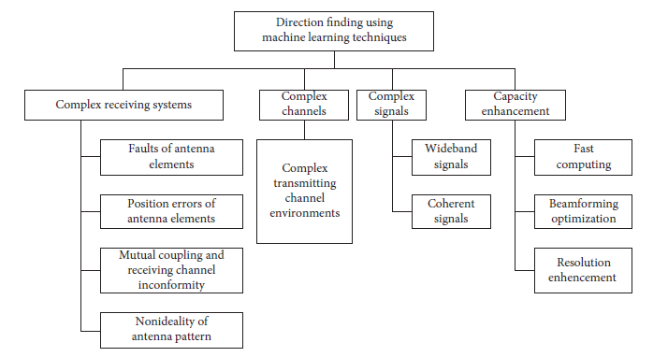

Figure . Overview of applications of ML in DOA [35].

## RESEARCH PROBLEM

The non-existence of a DOA method, with a simple system that detects the azimuth angle and the elevation angle, capable of responding to the needs of the next mobile communication networks and their main technologies such as BF.

## HYPOTHESIS

## OBJECTIVES

The main objective of this work is to propose a ML model to the azimuth and elevation angle of a signal coming from. To achieve the latter, the following specific objectives are considered:

* Design an antenna system to find DOA.
* Discuss training data preparation and designing for a specific scenario.
* Analyze different proposals to find both angles with ML models.
* Analyze different ML models.
* Select the best proposal to find the azimuth angle and elevation angle as well as the ML model from simulation results.

# CHAPTER 2: SIGNAL AND SYSTEM MODEL

We consider a system which consists of a single channel receiver, and $N$ direction antennas positioned uniformly forming a circle. The antenna array is connected to the receiver using a non-reflective Single-Pole-N-Throw (SPNT) RF switch, see Figure 3. The switching period is $T_{s}$.

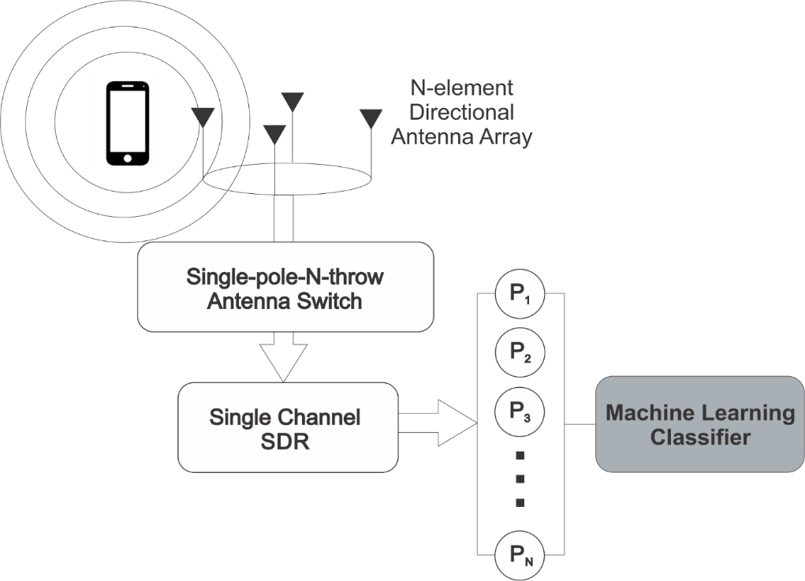

Figure 3. The System Model.

This work is based on the approach of the power received by each of the receiving antennas in the system. Then the resulting power received in each of the antennas is given by Friis formula:

|  |  |  |
| --- | --- | --- |
|  | $$P_{n}= P_{t}G_{t}G_{n}\frac{1}{L_{f}}$$ | Eq. 2 |
|  | $$P_{n}\left(dB\right)= P_{t}\left(dB\right)+G_{t}\left(dB\right)+G_{n}\left(dB\right)-L_{f}\left(dB\right)$$ | Eq. 3 |

Where $n$ $∈$ {1, …, $N$}, $P_{t}$ and $G_{t}$ are power and gain of the transmitting antenna respectively, $G_{n}$ is the gain of the receiving antenna and $λ$ is the signal wavelength (see Figure 4). $L_{f}$ is the effect of the propagation path, which causes $P_{r}$ to attenuate with the square of the distance $d_{n}$ to transmitting antenna, can be quantified by defining the free-space loss by

|  |  |  |
| --- | --- | --- |
|  | $$L_{f}={\left(\frac{4πd_{n}}{λ}\right)}^{2}$$ | Eq. 3 |

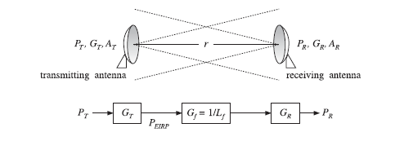

Figure . Transmitting and receiving antennas.

Such a gain model for communicating antennas is illustrated in Figures 3 and 4. An additional loss factor, $L_{other}$, may be introduced, if necessary, representing other losses, such as atmospheric absorption and scattering.

## Geometric Model

### Antennas coordinates

We consider a Cartesian coordinate system with orthogonal unit directions ($\hat{x},\hat{y},\hat{z}$) as a reference coordinate system. $N$ direction antennas are positioned uniformly forming a circle on the $x_y$ plane and the first antenna being at the $x$ axis (see Figure 5). The each of antennas have coordinate $\left(x_{n},y_{n},0\right)$ and the first antenna have coordinate $\left(x_{1},0,0\right)$. The antennas being uniformly distributed forming a circle will have a separation to the $x$ axis of:

|  |  |  |
| --- | --- | --- |
|  | $$φ_{n}=\frac{360*n}{N}$$ | Eq. 3 |

The radius of the circle formed by the antennas is denoted by $r$. Then the coordinates of the antennas are given by

|  |  |  |
| --- | --- | --- |
|  | $$x_{n}=r*cos\left(φ_{n}\right)$$ | Eq. 3 |
|  | $$y_{n}=r*sin\left(φ_{n}\right)$$ |  |
|  | $$z_{n}=0$$ |  |

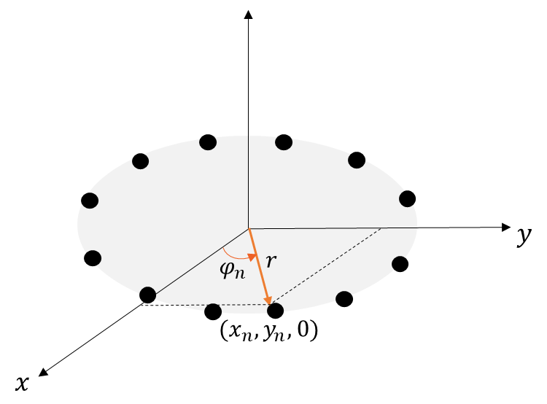

Figure . Antennas coordinates

### Transmisor coordinates

A transmitter at a distance $p$, which forms an azimuth angle $ϕ_{t}$ and elevation angle $θ_{t}$ with respect to the center of the coordinate axis, as is shown in Figure 6, will have the following coordinates

|  |  |  |
| --- | --- | --- |
|  | $$x_{t}=p'*cos\left(ϕ_{n}\right)$$ | Eq. 3 |
|  | $$y_{t}=p'*sin\left(ϕ_{n}\right)$$ |  |
|  | $$z_{t}=p*sin\left(θ_{t}\right)$$ |  |

where $p'$ is the projection of the vector $p$ in the x-y plane and will be given by

|  |  |  |
| --- | --- | --- |
|  | $$p^{'}=p*cos\left(θ_{t}\right)$$ | Eq. 3 |

Then the transmitter coordinates (equations 1,2) can be rewritten as

|  |  |  |
| --- | --- | --- |
|  | $$x_{t}=p*cos\left(θ_{t}\right)*cos\left(ϕ_{n}\right)$$ | Eq. 3 |
|  | $$y_{t}=p*cos\left(θ_{t}\right)*sin\left(ϕ_{n}\right)$$ |  |

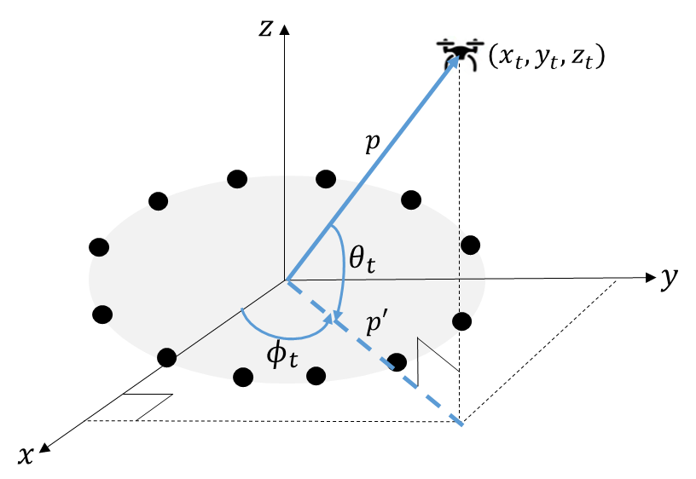

Figure . Transmisor coordinates

### Distance between transmitting antenna and receiving antennas

With the coordinates of the transmitting antenna and the coordinates of the transmitting antennas, the distance between the transmitter and the receiving antennas is calculated by the formula of the distance between two points in a Cartesian coordinate system (see Figure 7):

|  |  |  |
| --- | --- | --- |
|  | $$d_{n}=\sqrt{{\left(x_{t}-x_{n}\right)}^{2}+{\left(y_{t}-y_{n}\right)}^{2}+{\left(z_{t}-z_{n}\right)}^{2}}$$ | Eq. 3 |

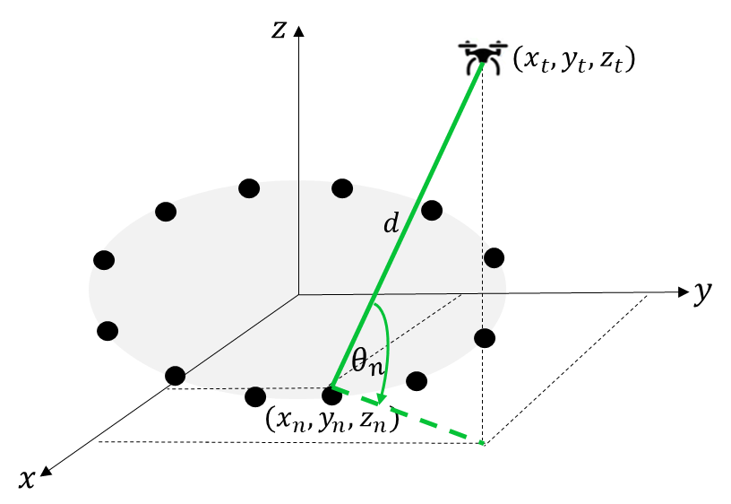

Figure . Distance between transmitting antenna and receiving antennas

### Angles between transmitting antenna and receiving antennas

In the Friis power it is observed that the received power will depend on the gain of the receiving antenna and the gain of the receiving antenna. If the antennas are not omni-directional, the value of these gains will depend on the angles that are formed between the receiving and transmitting antennas. Then equation 3 can be rewritten as

|  |  |  |
| --- | --- | --- |
|  | $$P_{n}= P_{t}G_{t}\left(β_{n},δ_{n}\right)G_{n}\left(ϕ_{n},θ_{n}\right)\frac{1}{L_{f}}$$ | Eq. 2 |

the angle $θ_{n}$ is shown in Figure 7 and is calculated as:

|  |  |  |
| --- | --- | --- |
|  | $$θ_{n}= arcsin\left(\frac{z_{t}}{d_{n}}\right)$$ | Eq. 2 |

The formula to calculate the angle between the receiving antenna in the plane depends on the comparison between the position of the receiving antenna and the transmitter, as shown in Figure 8.

Our objective is to recover the azimuth angle $ϕ$ and elevation angle $θ$, while the parameters $s\left(k\right)$ and $a_{n}\left(ϕ, θ\right)$ are unknown.

The proposed method is as follows. The receiver sequentially activates one antenna element at a time using the SPNT RF switch, and measures the corresponding received power value. During the activation of $n$-th antenna, $P_{n}$ is measured. A single switching cycle is equivalent to $N$ activations, starting from the first antenna to the $N$-th antenna. Let $p=\left[P_{1},…,P_{N}\right]$ denote the power measurements corresponding to a single switching cycle. Therefore, the ratio between $P_{n}$ and the summation of all power values within the same switching cycle can be given as:

|  |  |  |
| --- | --- | --- |
|  | $$x_{n}=\frac{P_{n}}{\sum_{l=1}^{N}{P_{l}}}$$ | Eq. 4 |

Let $x=\left[x_{1},…,x_{N}\right]$ denote the power measurements normalized corresponding to a single switching cycle. In the next section, we discuss how to recover $ϕ and θ$ from $x$ with ML.

Entonces el problema a resolver sería el siguiente, dado un dataset compuesto por diferentes x con sus valores respectivos de $ϕ and θ$, encontrar un clasificador capaz de encontrar con la mayor precisión posible los angulos $ϕ and θ$ de una señal proveniente.

## DOA estimation as a classification problem

To find the angle of azimuth and the angle of elevation from $x$ we consider three proposals:

1. Find the angle of azimuth and the angle of elevation independently: The problem of DOA estimation is divided into two independent classification problems: One to find the azimuth angle and the other to find the elevation angle.
2. Find the azimuth angle and the elevation angle with the same ML model instance.
3. Find the azimuth angle and the elevation angle with ML model multilabel, and multioutput.

### First proposal

All proposals are formulated as an $I$-class classification problem. In the first proposal, where there are two models to calculate the azimuth angle and the elevation angle respectively, each class corresponds to a possible DOA value in the set $ϕ = \{ϕ_{1},. . . , ϕ_{M}\}$ for the azimuth angle and $θ= \left\{θ_{1},…,θ_{P}\right\}$ for the elevation angle. The number of classes, $I$, depends on the resolution for discretization of the whole range of DOAs. Then the number of classes of the models to find the azimuth angle and the elevation angle will be given by:

|  |  |  |
| --- | --- | --- |
|  | $$I_{ϕ}=\frac{int\left[\left(ϕ_{M}-ϕ_{1}\right)\right]}{resolution}$$ | Eq. 5 |

The $int[]$ operator represents the integer conversion. For example, if the azimuth and the elevation angle’s ranges lie between [$0^{°}$, ${360}^{°}$] and [$0^{°}$, ${180}^{°}$] respectively, and both of them with a resolution of $1^{°}$, the number of classes is $I_{ϕ}$ = 360 and $I_{θ}$ = 180.

### Second proposal

For the second proposal, each class corresponds to a possible DOA value in in the set $φ = \{φ_{1},. . . , φ_{I}\}$ that combines azimuth angle with elevation angle. Therefore, the number of classes in this case is:

|  |  |  |
| --- | --- | --- |
|  | $$I_{φ}=\frac{int\left[\left(ϕ_{M}-ϕ_{1}\right)\right]×int\left[\left(θ_{P}-θ_{1}\right)\right]}{resolution}+2$$ | Eq. 6 |

Therefore, if the azimuth and the elevation angle’s ranges lie between [$0^{°}$, ${360}^{°}$] and [$0^{°}$, ${180}^{°}$] respectively, and both of them with a resolution of $1^{°}$, the total number of classes is $I_{φ}= 360×180$.

### Third proposal

The last proposal is a multilabel and multioutput classification problem, these means that each sample for the training of the problem will have multiple labels ( $ϕ$ and $θ$), and that the model will give more than one answer, the predicted $ϕ$ and $θ$ in this case. The class number that the model would have to determine would be the number of classes of the azimuth angle plus the number of classes of the elevation angle.

|  |  |  |
| --- | --- | --- |
|  | $$I_{Ω}=\frac{int\left[\left(ϕ_{M}-ϕ_{1}\right)\right]+int\left[\left(θ_{P}-θ_{1}\right)\right]}{resolution}$$ | Eq. 7 |

A supervised learning framework comprises of a training and a test phase. In the training phase, the DOA classifier is trained on a training data set, consisting of pairs of fixed dimension feature vectors and their corresponding DOA class labels. The fixed dimension feature vectors are given by $x$ and the labels by $ϕ$ and $θ$ for the first three proposals and by $φ$ for the last proposal. In the testing phase, given an input feature vector, the classification system generates the posterior probability for each of the $I$-classes. The class with higher probability is the DOA predicted class.

## Metrics and scoring

In this work, accuracy was used as a performance metric to compare the different proposals explained above and the ML models. If the entire set of predicted labels for a sample strictly match with the true set of labels, then the subset accuracy is 1.0; otherwise it is 0.0.

### First proposal

If ${\hat{y}}_{i}$ and ${\hat{z}}_{i}$ are the predicted value of the $i$ -th sample and $y_{i}$ and $z_{i}$ are the corresponding true value, then the fraction of correct predictions of models to calculate the azimuth angle and the elevation angle respectively, over $k$ samples is defined as:

|  |  |  |
| --- | --- | --- |
|  | $${accuracy}_{θ}\left(y,\hat{y}\right)=\frac{1}{k}\sum_{i=0}^{k-1}{1({\hat{y}}_{i}=y_{i})}$$ | Eq. 8 |
|  | $${accuracy}_{ϕ}\left(z,\hat{z}\right)=\frac{1}{k}\sum_{i=0}^{k-1}{1({\hat{z}}_{i}=z_{i})}$$ | Eq. 9 |

where $1(x)$ is the indicator function.Being independent events, the accuracy of the first proposal will be given by:

|  |  |  |
| --- | --- | --- |
|  | $${accuracy}_{1^{st} proposal}={{accuracy}_{θ}*accuracy}_{ϕ}$$ | Eq. 10 |

### Second proposal

Because in the second proposal we will be in a multiclass problem, and not multioutput, the accuracy of this proposal will be given by the same form of equations 8 and 9:

|  |  |  |
| --- | --- | --- |
|  | $${accuracy}_{φ}\left(t,\hat{t}\right)=\frac{1}{k}\sum_{i=0}^{k-1}{1({\hat{t}}_{i}=t_{i})}$$ | Eq. 11 |

where $t$ and $\hat{t}$ are the true value and predict value respectively. The difference is that the model will have a greater number of classes to differentiate, so it is logical that the value in 11 is always less than the one given by 8 and 9.

### Third proposal

In this case, the accuracy will be greater the more times the model has predicted the real value of the azimuth angle and the elevation angle simultaneously. Then the calculation of the accuracy in the third proposal will be given by:

|  |  |  |
| --- | --- | --- |
|  | $${accuracy}_{Ω}\left(y,\hat{y},z,\hat{z}\right)=\frac{1}{k}\sum_{i=0}^{k-1}{1({\hat{y}}_{i}=y_{i} and {\hat{z}}_{i}=z_{i})}$$ | Eq. 12 |

## Classification model

In this subsection a brief review of the ML model and the ensemble methods used in this work is given. This work uses the *Scikit-Learn* (*sklearn)* library [36] for ML models and their best performance.

### Support Vector Classification (SVC):

SVC tries to find the best hyperplane to separate different classes by maximizing the distance between sample points and the hyperplane. The SVC model [37] takes as input the following parameters:

* *kernel*: Selects the type of hyperplane used to separate the data. It must be one of linear, *poly*, *rbf*, *sigmoid*, *precomputed* or a callable.
* *C*: Is the penalty parameter of the error term. It controls the trade off between smooth decision boundary and classifying the training points correctly.
* *gamma*: Kernel coefficient for *rbf*, *poly* and *sigmoid*.

### Decision Trees (DT):

DT models are one of the simplest and yet most successful forms of ML models [38]. The goal of DT is to create a model that predicts the value of a target variable by learning simple rules inferred from the data features. The DT models build a tree during training that is the one applied when making the prediction. The input and output values can be discrete or continues. The *DecisionTreeClassifier* class, from the *Scikit-Learn* (*sklearn)* library, supports multi-output problems [39] and; therefore, this model can be used in the two proposals explained in the last section. In this work, the *DecisionTreeClassifier* class takes as input the following parameters:

* *max_depth*: This indicates how deep the tree can be.

### Extra Decision Trees (EDT):

Extra-trees differ from classic decision trees in the way they are built. *ExtraTreeClassifier* [40] is a randomized version of *DecisionTreeClassifier* meant to be used internally as part of ensemble methods. The parameters that we take into account in the model are the same as in DT.

### Bagging Classifier (BC)

It is an ensemble meta-estimator that fits base classifiers each on random subsets of the original dataset and then aggregates their individual predictions (either by voting or by averaging) to form a final prediction [41]. In this work, the BC takes as input the following parameters:

* *base_estimator*: Applied to random subsets of the dataset. The base classifier used was DT.
* *n_estimators*: The number of base estimators (in this case, the number of DT) in the ensemble.
* *max _samples*: The number of samples to extract from the training data to train each base estimator.
* *bootstrap*: Parameter which defines whether samples are drawn with replacement. If *False*, sampling without replacement is performed.
* *n_jobs*: Tells *Scikit-Learn* the number of CPU cores to use for training and prediction. *n_jobs* is *None* by default, which means unset; it will generally be interpreted as *n jobs* = 1 which means that only one core will be used by *Scikit-Learn*. *n_jobs* = -1 tells *Scikit-Learn* library to use all available cores. For *n_jobs* below -1, number of cores + 1 + *n_jobs* are used. For example, with *n_jobs* = -2, all CPUs but one is used.
* *random_state*: Provided to control the random number generator used. The values of random state can be: *None* (default), an integer, and a *numpy.random*.*RandomState* instance. *random state*= *None* calls the function multiple times, it will reuse the same instance, and it will produce different results. If *random_state* is an integer, it is going to use a new random number generator seeded by the given integer. Using an integer will produce the same results across different calls. Popular integer random seeds are 0 and 42. The *numpy.random.RandomState* instance uses the provided random state, only affecting other users of that same random state instance.

# CHAPTER 3: SIMULATION RESULTS

## DATA GENERATION

The proposed ML-based approaches are evaluated and compared on simulated scenario. The simulations are implemented with Mathlab and executed on an MSI laptop with a Core i7 processor, a 16 GB RAM, and a 16 GB NVIDIA GeForce RTX 2070 video card. The simulation scenario consists of a UCA arrangement of $N$ receiving dipole antennas. The radius of the UCA is equal to half of the wavelength, $d= λ/2$.

To collect the data samples, we employ the method described in chapter 2 to simulate the power arriving to the antennas from different directions. It means, for each pair of azimuth and elevation angles $(ϕ_{i},θ_{j})$, the corresponding power received at each antenna ($n$) was obtained. The azimuth and elevation angles are in a range of [$0^{0}$: ${360}^{0}$) and [$0^{0}$: ${180}^{0}$) respectively with an angle resolution of $5^{0}$. Hence the data samples are formed by the corresponding power received at each antenna ($p_{i,j}=\left[p_{i,j,1},…,p_{i,j,N}\right]$) and the direction information $(ϕ_{i},θ_{j})$. For each angle pair, 500 samples were generated. In this way, the total number of data generated is 6480000 (${samples×\left(ϕ_{M}-ϕ_{1}\right)×\left(θ_{P}-θ_{1}\right)}/{resolution}$) to each antenna. The training dataset is 80% of the total number of snapshots and the validation dataset is 20% of the total number of snapshots. In the next section, the necessary and sufficient number of antennas ($N$) that the receiving system must have will be analyzed in such a way that it has a good performance but that is as simple as possible.

|  |  |  |
| --- | --- | --- |
|  |  | Eq. |
|  |  |  |
|  |  |  |

~~We assumed that required angle resolution was $5^{0}$ and that the search range of DOA was between $1^{0}$ and ${360}^{0}$. We used L snapshots of received signals per angle in each simulation. Therefore, the total number of snapshots will be given by $L_{t} = {L*360}/{resolution}$. The training dataset is 80% of the total number of snapshots and the validation dataset is 20% of the total number of snapshots.~~

~~. The received signals are synthesized from the radiation pattern of the receiving dipole antennas with the addition of Gaussian white noise. Las potencias transmitidas se generaron en un rango entre [tao-tao](que es el rango de potencia en que trabajan las senales). Y el ruido de las antenas se asumió como la mitad del angulo de potencia maxima. De esa forma se generan datos con diferentes SNR.~~

## SYSTEM MODEL DESIGN

Figure 3 shows the accuracy performance of the DOA estimation against $N$ for each proposal. The SNR was assumed to be 20 dB for each simulation.

(AQUÍ VA LA FIGURA, UNA PARA CADA PROPUESTA(a,b,c))

The parameters of each model have been selected using the method *GridSearchCV* of the class *sklearn.model_selection* [42]*.* Table 1 shows the parameters that were decided using that method and their respective ranges of parameters to take into account.

Table . Input parameter values of the GridSearchCV.

|  |  |  |
| --- | --- | --- |
| ML model | Parameter | Values |
| DT | *max_depth* | 10-110 with jumps of 10 |
| RF |  |  |
| SVR |  |  |
|  |  |  |
|  |  |  |

It can be seen from Figure x that

## ANALYSIS OF ML MODELS

## RESULTS

# References

[1] Z. Zhang *et al.*, “6G Wireless Networks: Vision, Requirements, Architecture, and Key Technologies,” *IEEE Veh. Technol. Mag.*, vol. 14, no. 3, pp. 28–41, Sep. 2019, doi: 10.1109/MVT.2019.2921208.

[2] B. Zong, C. Fan, X. Wang, X. Duan, B. Wang, and J. Wang, “6G Technologies: Key Drivers, Core Requirements, System Architectures, and Enabling Technologies,” *IEEE Veh. Technol. Mag.*, vol. 14, no. 3, pp. 18–27, Sep. 2019, doi: 10.1109/MVT.2019.2921398.

[3] M. Z. Chowdhury, Md. Shahjalal, S. Ahmed, and Y. M. Jang, “6G Wireless Communication Systems: Applications, Requirements, Technologies, Challenges, and Research Directions,” *IEEE Open J. Commun. Soc.*, vol. 1, pp. 957–975, 2020, doi: 10.1109/OJCOMS.2020.3010270.

[4] S. Elmeadawy and R. M. Shubair, “Enabling Technologies For 6g Future Wireless Communications: Opportunities And Challenges,” *ArXiv200206068 Eess*, Feb. 2020, Accessed: May 12, 2021. [Online]. Available: http://arxiv.org/abs/2002.06068

[5] R. Avtar and T. Watanabe, Eds., *Unmanned Aerial Vehicle: Applications in Agriculture and Environment*. Cham: Springer International Publishing, 2020. doi: 10.1007/978-3-030-27157-2.

[6] M. S. Allahham, T. Khattab, and A. Mohamed, “Deep Learning for RF-Based Drone Detection and Identification: A Multi-Channel 1-D Convolutional Neural Networks Approach,” in *2020 IEEE International Conference on Informatics, IoT, and Enabling Technologies (ICIoT)*, Doha, Qatar, Feb. 2020, pp. 112–117. doi: 10.1109/ICIoT48696.2020.9089657.

[7] H. Shakhatreh *et al.*, “Unmanned Aerial Vehicles (UAVs): A Survey on Civil Applications and Key Research Challenges,” *IEEE Access*, vol. 7, pp. 48572–48634, 2019, doi: 10.1109/ACCESS.2019.2909530.

[8] “Lufthansa jet and drone nearly collide near LAX - Los Angeles Times.” https://www.latimes.com/local/lanow/la-me-ln-drone-near-miss-lax-20160318-story.html (accessed May 13, 2021).

[9] R. K. Miranda, D. A. Ando, J. P. C. L. da Costa, and M. T. de Oliveira, “Enhanced Direction of Arrival Estimation via Received Signal Strength of Directional Antennas,” in *2018 IEEE International Symposium on Signal Processing and Information Technology (ISSPIT)*, Louisville, KY, USA, Dec. 2018, pp. 162–167. doi: 10.1109/ISSPIT.2018.8642668.

[10] M. Pesavento and A. B. Gershman, “Maximum-likelihood direction-of-arrival estimation in the presence of unknown nonuniform noise,” *IEEE Trans. Signal Process.*, vol. 49, no. 7, pp. 1310–1324, Jul. 2001, doi: 10.1109/78.928686.

[11] F. Athley, “Threshold region performance of maximum likelihood direction of arrival estimators,” *IEEE Trans. Signal Process.*, vol. 53, no. 4, pp. 1359–1373, Apr. 2005, doi: 10.1109/TSP.2005.843717.

[12] X. Xu, X. Wei, and Z. Ye, “DOA Estimation Based on Sparse Signal Recovery Utilizing Weighted $l_{1}$-Norm Penalty,” *IEEE Signal Process. Lett.*, vol. 19, no. 3, pp. 155–158, Mar. 2012, doi: 10.1109/LSP.2012.2183592.

[13] D. Malioutov, M. Cetin, and A. S. Willsky, “A sparse signal reconstruction perspective for source localization with sensor arrays,” *IEEE Trans. Signal Process.*, vol. 53, no. 8, pp. 3010–3022, Aug. 2005, doi: 10.1109/TSP.2005.850882.

[14] M. S. Lobo, L. Vandenberghe, S. Boyd, and H. Lebret, “Applications of second-order cone programming,” *Linear Algebra Its Appl.*, vol. 284, no. 1–3, pp. 193–228, Nov. 1998, doi: 10.1016/S0024-3795(98)10032-0.

[15] V. Cevher, A. C. Gurbuz, J. H. McClellan, and R. Chellappa, “Compressive wireless arrays for bearing estimation,” in *2008 IEEE International Conference on Acoustics, Speech and Signal Processing*, Las Vegas, NV, USA, Mar. 2008, pp. 2497–2500. doi: 10.1109/ICASSP.2008.4518155.

[16] C. Zheng, G. Li, H. Zhang, and X. Wang, “An approach of DOA estimation using noise subspace weighted &#x2113;1 minimization,” in *2011 IEEE International Conference on Acoustics, Speech and Signal Processing (ICASSP)*, Prague, Czech Republic, May 2011, pp. 2856–2859. doi: 10.1109/ICASSP.2011.5947080.

[17] J. Dai, D. Zhao, and X. Ji, “A Sparse Representation Method for DOA Estimation With Unknown Mutual Coupling,” *IEEE Antennas Wirel. Propag. Lett.*, vol. 11, pp. 1210–1213, 2012, doi: 10.1109/LAWP.2012.2223651.

[18] X. Zhang, T. Jiang, Y. Li, and Y. Zakharov, “A Novel Block Sparse Reconstruction Method for DOA Estimation With Unknown Mutual Coupling,” *IEEE Commun. Lett.*, vol. 23, no. 10, pp. 1845–1848, Oct. 2019, doi: 10.1109/LCOMM.2019.2929384.

[19] H. Fu, S. Abeywickrama, C. Yuen, and M. Zhang, “A Robust Phase-Ambiguity-Immune DOA Estimation Scheme for Antenna Array,” *IEEE Trans. Veh. Technol.*, vol. 68, no. 7, pp. 6686–6696, Jul. 2019, doi: 10.1109/TVT.2019.2916171.

[20] E. J. Candes, J. Romberg, and T. Tao, “Robust uncertainty principles: exact signal reconstruction from highly incomplete frequency information,” *IEEE Trans. Inf. Theory*, vol. 52, no. 2, pp. 489–509, Feb. 2006, doi: 10.1109/TIT.2005.862083.

[21] Z. Liu, C. Zhang, and P. S. Yu, “Direction-of-Arrival Estimation Based on Deep Neural Networks With Robustness to Array Imperfections,” *IEEE Trans. Antennas Propag.*, vol. 66, no. 12, pp. 7315–7327, Dec. 2018, doi: 10.1109/TAP.2018.2874430.

[22] K. Terabayashi, R. Natsuaki, and A. Hirose, “Ultrawideband Direction-of-Arrival Estimation Using Complex-Valued Spatiotemporal Neural Networks,” *IEEE Trans. Neural Netw. Learn. Syst.*, vol. 25, no. 9, pp. 1727–1732, Sep. 2014, doi: 10.1109/TNNLS.2014.2313869.

[23] X. Xiao, S. Zhao, X. Zhong, D. L. Jones, E. S. Chng, and H. Li, “A learning-based approach to direction of arrival estimation in noisy and reverberant environments,” in *2015 IEEE International Conference on Acoustics, Speech and Signal Processing (ICASSP)*, Apr. 2015, pp. 2814–2818. doi: 10.1109/ICASSP.2015.7178484.

[24] Y. Kase, T. Nishimura, T. Ohgane, Y. Ogawa, D. Kitayama, and Y. Kishiyama, “DOA Estimation of Two Targets with Deep Learning,” in *2018 15th Workshop on Positioning, Navigation and Communications (WPNC)*, Oct. 2018, pp. 1–5. doi: 10.1109/WPNC.2018.8555814.

[25] A. Barthelme and W. Utschick, “A Machine Learning Approach to DoA Estimation and Model Order Selection for Antenna Arrays with Subarray Sampling,” *ArXiv200912858 Eess*, Sep. 2020, Accessed: Jan. 26, 2021. [Online]. Available: http://arxiv.org/abs/2009.12858

[26] Y. Guo, Z. Zhang, Y. Huang, and P. Zhang, “DOA Estimation Method Based on Cascaded Neural Network for Two Closely Spaced Sources,” *IEEE Signal Process. Lett.*, vol. 27, pp. 570–574, 2020, doi: 10.1109/LSP.2020.2984914.

[27] H. Huang, J. Yang, H. Huang, Y. Song, and G. Gui, “Deep Learning for Super-Resolution Channel Estimation and DOA Estimation Based Massive MIMO System,” *IEEE Trans. Veh. Technol.*, vol. 67, no. 9, pp. 8549–8560, Sep. 2018, doi: 10.1109/TVT.2018.2851783.

[28] S. Abeywickrama, L. Jayasinghe, H. Fu, S. Nissanka, and C. Yuen, “RF-based Direction Finding of UAVs Using DNN,” in *2018 IEEE International Conference on Communication Systems (ICCS)*, Chengdu, China, Dec. 2018, pp. 157–161. doi: 10.1109/ICCS.2018.8689177.

[29] M. Pastorino and A. Randazzo, “A smart antenna system for direction of arrival estimation based on a support vector regression,” *IEEE Trans. Antennas Propag.*, vol. 53, no. 7, pp. 2161–2168, Jul. 2005, doi: 10.1109/TAP.2005.850735.

[30] A. Randazzo, M. A. Abou-Khousa, M. Pastorino, and R. Zoughi, “Direction of Arrival Estimation Based on Support Vector Regression: Experimental Validation and Comparison With MUSIC,” *IEEE Antennas Wirel. Propag. Lett.*, vol. 6, pp. 379–382, 2007, doi: 10.1109/LAWP.2007.903491.

[31] M. Donelli, F. Viani, P. Rocca, and A. Massa, “An Innovative Multiresolution Approach for DOA Estimation Based on a Support Vector Classification,” *IEEE Trans. Antennas Propag.*, vol. 57, no. 8, pp. 2279–2292, Aug. 2009, doi: 10.1109/TAP.2009.2024485.

[32] J. Pan, Y. Wang, C. Le Bastard, and T. Wang, “DOA Finding with Support Vector Regression Based Forward–Backward Linear Prediction,” *Sensors*, vol. 17, no. 6, Art. no. 6, Jun. 2017, doi: 10.3390/s17061225.

[33] Z.-T. Huang, L.-L. Wu, and Z.-M. Liu, “Toward wide-frequency-range direction finding with support vector regression,” *IEEE Commun. Lett.*, vol. 23, no. 6, pp. 1029–1032, 2019.

[34] L.-L. Wu and Z.-T. Huang, “Coherent SVR Learning for Wideband Direction-of-Arrival Estimation,” *IEEE Signal Process. Lett.*, vol. 26, no. 4, pp. 642–646, Apr. 2019, doi: 10.1109/LSP.2019.2901641.

[35] M.-Y. You, A.-N. Lu, Y.-X. Ye, K. Huang, and B. Jiang, “A Review on Machine Learning-Based Radio Direction Finding,” *Math. Probl. Eng.*, vol. 2020, pp. 1–9, Aug. 2020, doi: 10.1155/2020/8345413.

[36] “scikit-learn: machine learning in Python — scikit-learn 0.24.2 documentation.” https://scikit-learn.org/stable/ (accessed May 12, 2021).

[37] “1.4. Support Vector Machines — scikit-learn 0.24.2 documentation.” https://scikit-learn.org/stable/modules/svm.html (accessed May 12, 2021).

[38] J. Stuart, “Russell & Peter Norvig: Artificial Intelligence: A Modern Approach,” *Prentice-Hall*, 2003.

[39] “1.10. Decision Trees — scikit-learn 0.24.1 documentation.” https://scikit-learn.org/stable/modules/tree.html (accessed Mar. 23, 2021).

[40] “sklearn.tree.ExtraTreeClassifier — scikit-learn 0.24.2 documentation.” https://scikit-learn.org/stable/modules/generated/sklearn.tree.ExtraTreeClassifier.html#sklearn.tree.ExtraTreeClassifier (accessed May 24, 2021).

[41] “sklearn.ensemble.BaggingClassifier — scikit-learn 0.24.1 documentation.” https://scikit-learn.org/stable/modules/generated/sklearn.ensemble.BaggingClassifier.html (accessed Mar. 23, 2021).

[42] “sklearn.model_selection.GridSearchCV — scikit-learn 0.24.2 documentation.” https://scikit-learn.org/stable/modules/generated/sklearn.model_selection.GridSearchCV.html (accessed May 29, 2021).